1. To display the job-wise count of employees in each department as follows: -

**DEPTNO JOB NUM_EMP**

SELECT D. DEPTNO, D. DNAME, COUNT ('E. EMPNO') "NUMBER OF EMPLOYEES"FROM DEPT D, EMP EWHERE D. DEPTNO = E. DEPTNO GROUP BY D. DEPTNO, D. DNAME;

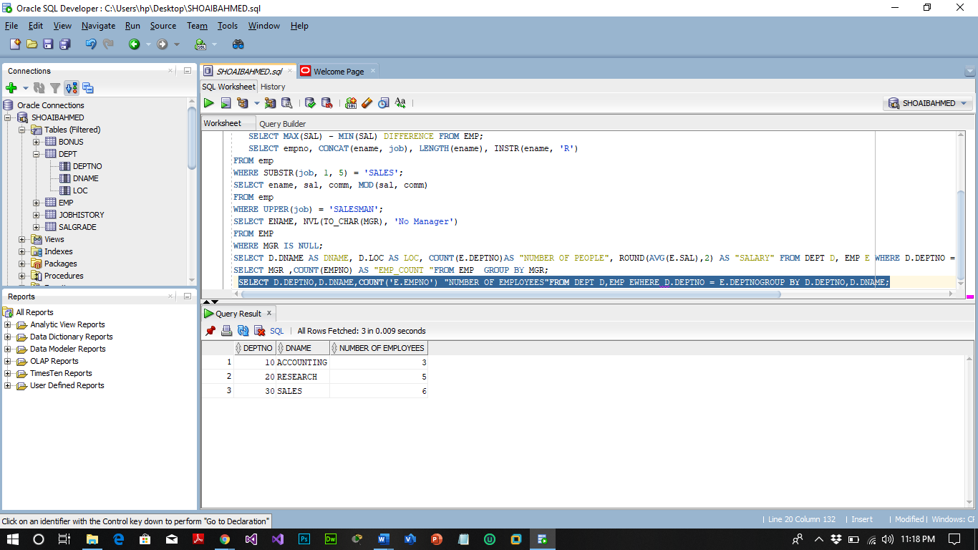

1. To display the department name, location name, number of employees and the average salary for all employees in that department. Label the columns DNAME, LOC, NUMBER OF PEOPLE and SALARY, respectively. Round the average salary to two decimal places.

SELECT D. DNAME AS DNAME, D.LOC AS LOC, COUNT (E. DEPTNO) AS "NUMBER OF PEOPLE", ROUND(AVG(E.SAL),2) AS "SALARY" FROM DEPT D, EMP E WHERE D. DEPTNO = E. DEPTNO GROUP BY D. DNAME, D.LOC, E. DEPTNO;

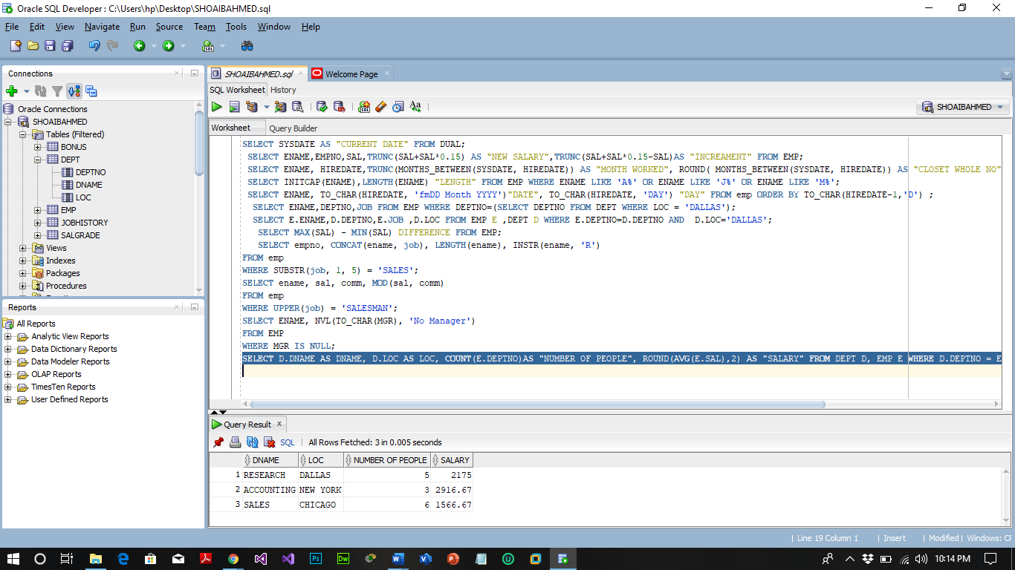

1. To display the employee name, department number and job title for all employees whose department location is *Dallas*.

SELECT ENAME, DEPTNO, JOB FROM EMP WHERE DEPTNO= (SELECT DEPTNO FROM DEPT WHERE LOC = 'DALLAS');

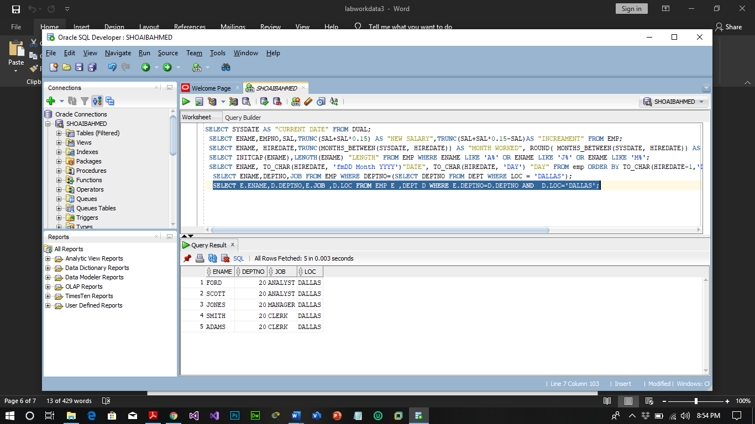

1. To display the difference between the highest and lowest salaries (Labeled as

*DIFFERENCE*)

SELECT MAX(SAL) - MIN(SAL) DIFFERENCE FROM EMP;

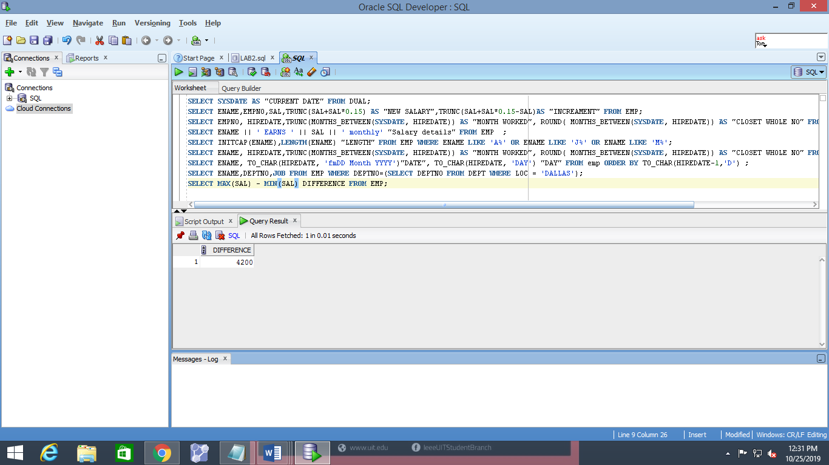

1. To show the manager name, MANAGER, and the number of employees, NUM, working under him.

SELECT MGR, COUNT(EMPNO) AS "EMP_COUNT "FROM EMP GROUP BY MGR;

